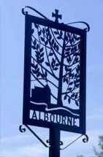
ALBOURNE PARISH COUNCIL
Invites you
To the Annual General
Meeting of the Parish
on Tuesday, 24th May 2021
at 7.30 p.m.
_________________________________
Please note that this meeting will be held via the zoom platform, as even though legal restrictions have been lifted, it is still not considered safe to hold this in the Village Hall.
The Agenda for the meeting will be published on the 13th May, and full details of how to join the meeting by zoom, will be included then. Please note that you will be asked to give your name in order to be able to join the meeting.
We hope that you will be able to join us, as this is your chance to have your say with Parish, District and County Councillors present on any issues
that concern or affect you!

