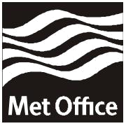
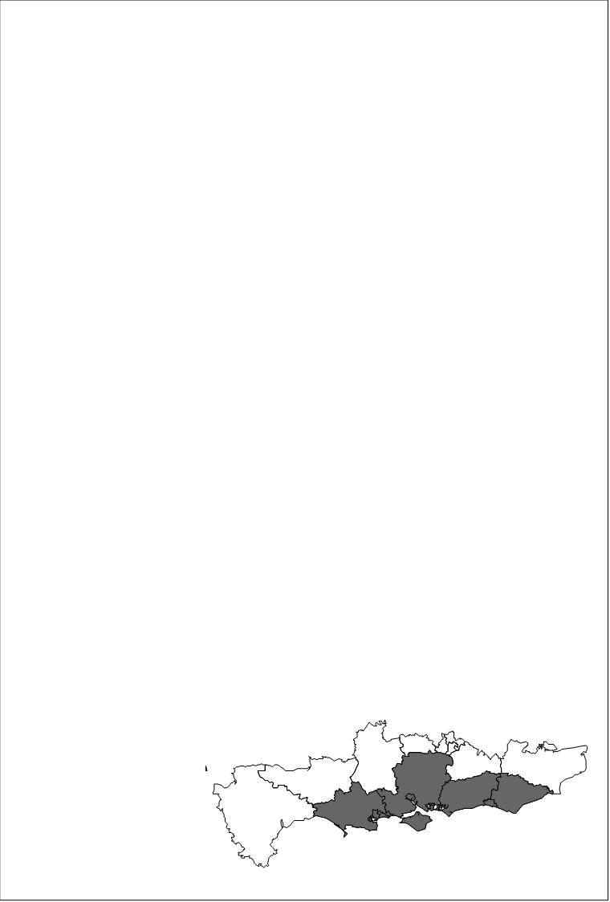
National Severe Weather Warning Service
F L A S H W A R N I N G
Flash Warning of • Heavy Rain
For the following areas • Bournemouth • Brighton + Hove • Dorset • E Sussex • Hampshire • Isle of Wight • Poole • Portsmouth • Southampton • W Sussex
Heavy rain this evening and overnight is expected to give accumulations of 50-70 mm in places.
The public are advised to take extra care and refer to the Highways Agency for further advice on traffic disruption on motorways and trunk roads.
Issued by the Met Office at 20:18 on Monday, 08th November 2010
Valid from 22:30 on Monday, 08th November 2010 until 10:00 on Tuesday, 09th November 2010
For enquiries regarding this warning then please contact the Met Office Customer Centre. Phone: 0870 900 0100 Fax: 0870 900 5050 Email: enquiries@metoffice.gov.uk

